**Sprint 3 Report, Detective Dollar**

Detective Dollar Team. Completion by Monday 11/26/23

**Actions to stop doing:**

* The team should discontinue addressing individual issues early in the meetings and instead start each meeting with a general overview of the three key questions: What have you done? What are you going to do? Any challenges. This will help streamline our meeting process and prioritize the discussion of challenges effectively.

**Actions to start doing:**

* The team should enhance our weekly meetings by creating a more concrete outline of what we aim to discuss and accomplish. A structured agenda will ensure that our meetings are more productive and organized.
* The team should start tracking how long it takes to complete user stories to improve our estimation and planning processes.

**Actions to keep doing:**

* We should continue frequently voicing our concerns and challenges during our meetings to ensure any potential issues are addressed promptly.
* We should keep updating each other on individual tasks in our Discord channel to promote collaboration and keep everyone informed about ongoing progress.

**Work completed/not completed:**

* Completed User Stories

1. As a user, I will be able to look at my previous daily, monthly, and yearly expenses
2. As a user, I will be able to see my past expenses in a line graph to see past trends in my spending

3. As a user, when adding an expense, I can add an image of the bill or receipt

6. As a user, my expenses and expense charts will be displayed in my local time

* Not Completed (Functionality done but still working on UI)

4. As a user, I will receive a pop-up when adding expenses to confirm my new expense

5. As a user, when adding expenses, I can select a previously made category or add a new one

7. As a user, after I add an expense, the input fields will be cleared so that I can easily add a new expense

**Work completion rate:**

In Sprint 1, the team successfully completed 4 out of 7 user stories. While we were unable to determine the exact number of hours it took each team member to complete the user stories, we did have initial estimates in our Sprint 1 plan for each user story. These estimates were as follows:

Total for User Story: 6 hours

* Total for User Story 1: Estimated at 6 hour.
* Total for User Story 2: Estimated at 4 hours.
* Total for User Story 3: Estimated at 6.5 hours.
* Total for User Story 4: Estimated at 2 hours.
* Total for User Story 5: Estimated at 5.5 hours.
* Total for User Story 6: Estimated at 3 hours.
* Total for User Story 7: Estimated at 2 hours.

In the future, we plan to do a better job of estimating the time it takes to complete user stories and use this information to enhance our estimation and planning processes for upcoming sprints.

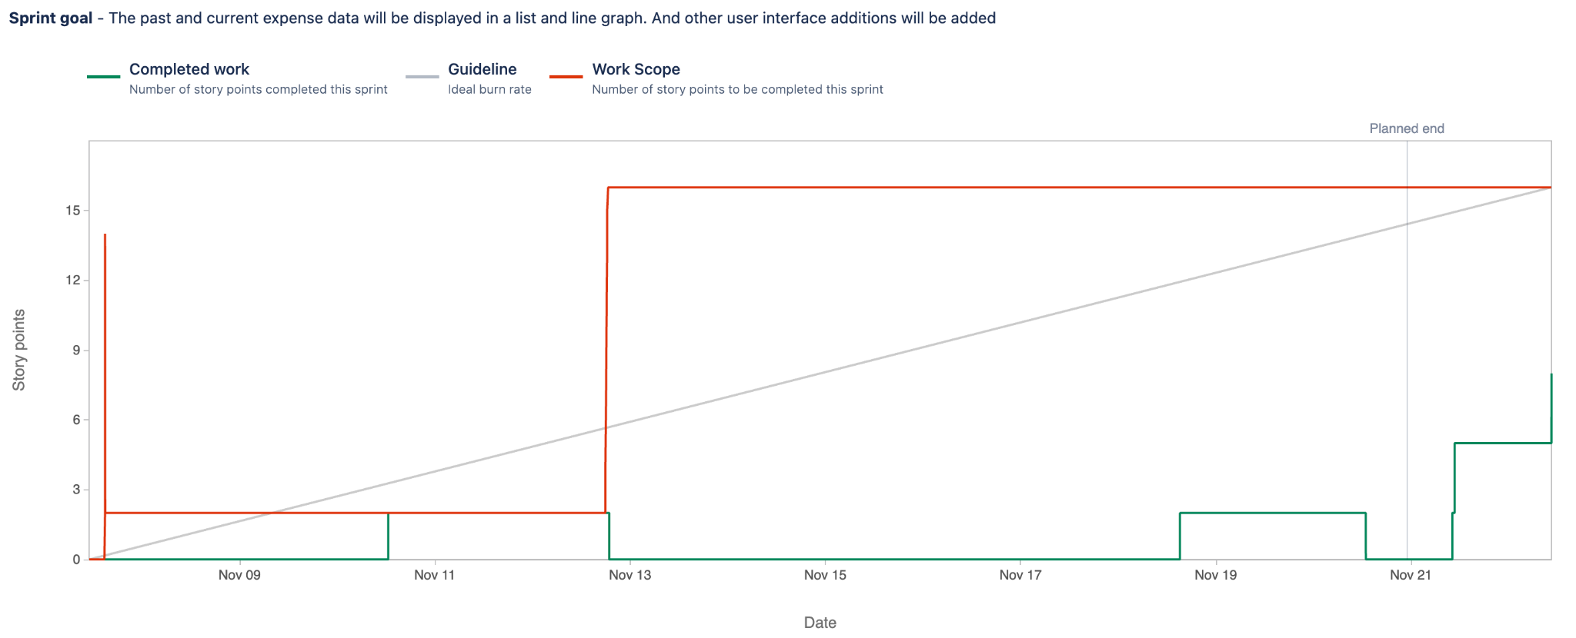

Based on the Burnup chart, we observed that we were behind schedule most of the sprint. This is because we got behind schedule and finalized our sprint plan halfway through the sprint. Based on our meeting times, our burnup chart also got updated later, thus making it seem like we had completed less in the actual sprint timeframe. Our Sprint 4 is mainly on updating the UI for the app, which is also why some of our tasks/ user stories got delayed as the user stories overlap.